Low Level Design

Amazon Food Sales Data Analysis

Revision Number: 1.0 Last date of revision: 05/03/2023

Ritesh Admane

**Document Version Control**

|  |  |  |  |
| --- | --- | --- | --- |
| **Date Issued** | **Version** | **Description** | **Author** |
| **05/03/2023** | 1.0 | First Version of Complete LLD | Ritesh Admane |
|  |  |  |  |
|  |  |  |  |
|  |  |  |  |
|  |  |  |  |
|  |  |  |  |
|  |  |  |  |

Contents

1. Introduction 4

1.1 What is Low-Level design document? 4

1.2 Scope 4

2. Architecture 5

1. Data Sources 5

2. Power BI Desktop 6

3. Power BI Service 6

4. Power BI Report Server 6

5. Power BI Gateway 6

6. Power BI Mobile 6

7. Power BI Embedded 6

3. ARCHITECTURE DESCRIPTION 7

3.1 Data Description 7

3.2 Data Loading 7

3.3 Data Transformation 8

3.3 Data Modelling 8

3.4 DEPLOYMENT: 9

4. UNIT TEST CASES 10

# 1. Introduction

### 1.1 What is Low-Level design document?

The goal of the LDD or Low-level design document (LLDD) is to give the internal logic design of the actual program code for the House Price Prediction dashboard. LDD describes the class diagrams with the methods and relations between classes and programs specs. It describes the modules so that the programmer can directly code the program from the document.

### 1.2 Scope

Low-level design (LLD) is a component-level design process that follows a step-by-step refinement process. The process can be used for designing data structures, required software architecture, source code and ultimately, performance algorithms. Overall, the data organization may be defined during requirement analysis and then refined during data design work.

# 2. Architecture

Power BI is a business suite that includes several technologies that work together. To deliver outstanding business intelligence solutions, Microsoft Power BI technology consists of a group of components such as:

* Power Query (for data mash-up and transformation)
* Power BI Desktop (a companion development tool)
* Power BI Mobile (for Android, iOS, Windows phones)
* Power Pivot (for in-memory tabular data modeling)
* Power View (for viewing data visualizations)
* Power Map (for visualizing 3D geo-spatial data)
* Power Q&A (for natural language Q&A)

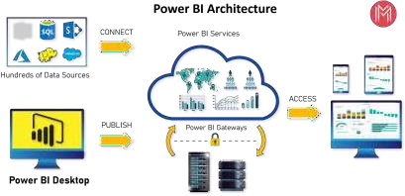

## 1. Data Sources

An important component of Power BI is its vast range of data sources. You can import data from files in your system, cloud-based online data sources or connect directly to live connections. If you import from data on-premise or online services there is a limit of 1 GB. Some commonly used data sources in Power BI are:

* Excel
* Text/CSV
* XML
* JSON
* Oracle Database
* IBM DB2 Database
* MySQL Database
* PostgreSQL Database
* Sybase Database
* Teradata Database
* SAP HANA Database
* SAP Business Warehouse server
* Amazon Redshift
* Impala
* Google BigQuery (Beta)
* Azure SQL Database
* Salesforce Reports
* Google Analytics
* Facebook
* GitHub

## 2. Power BI Desktop

*Power BI Desktop is a client-side tool known as a companion development and authoring tool. This desktop-based software is loaded with tools and functionalities to* connect to data sources, transform data, data modeling and creating reports.

## 3. Power BI Service

Power BI Service is a web-based platform from where you can *share reports made on Power BI Desktop, collaborate with other users, and create dashboards.*

It is available in three versions:

* Free version
* Pro version
* Premium version

Power BI Service is also known as, **“Power BI.com”**, **“Power BI Workspace”, “Power BI Site”** and **“Power BI Web Portal”**. This component also offers advanced features like *natural language Q&A* and *alerts*.

## 4. Power BI Report Server

The Power BI Report Server is similar to the Power BI Service. The only difference between these two is that Power BI Report Server is an on-premise platform. It is used by organizations who do not want to publish their reports on the cloud and are concerned about the security of their data.

Power BI Report Server enables you to create dashboards and share your reports with other users following proper security protocols. To use this service, you need to have a Power BI Premium license.

## 5. Power BI Gateway

This component is used to connect and access on-premise data in secured networks. Power BI Gateways are generally used in organizations where data is kept in security and watch. Gateways help to extract out such data through secure channels to Power BI platforms for analysis and reporting.

## 6. Power BI Mobile

Power BI Mobile is a native Power BI application that runs on iOS, Android, and Windows mobile devices. For viewing reports and dashboards, these applications are used.

## 7. Power BI Embedded

Power BI Embedded offers APIs which are used to embed visuals into custom applications.

# 3. ARCHITECTURE DESCRIPTION

### 3.1 Data Description

The dataset contains two tables Customer and Sales data of Amazon for the year 2017,2018,2019

**Amazon Sales Data Features**

1. Custkey – It is a Unique Id used to define a customer.
2. Datekey – It is the date on which transaction took place.
3. Discount amount – It is the difference between Sales amount based on list price and Sales amount.
4. Invoice Date – It is the date on Which the Ordered delivered and invoice created.
5. Invoice Number – It is a Unique number generated by the system after making of invoice
6. Item Class – It is the class of the Item.
7. Item Number – It is a Unique number used to define an item.
8. Item – It is the name of the item for which transaction took place.
9. Line Number – It is the number of line from which it is ordered.
10. List Price – It is the price quoted by the manufacturer.
11. Order Number – It is the Unique Number for the particular order.
12. Promised delivery date – It is the date provided on which delivery is expected.
13. Sales Amount – It is the Product of Sales Price and Quantity.
14. Sales amount based on List Price – It is the product of List price and Quantity.
15. Sales Cost amount – It is the amount caused for making sales of the item.
16. Sales Margin amount - It is the difference between Sales amount and Sales cost amount.
17. Sales Price – It is the price at which Item is Sold.
18. Sales Quantity – It is the quantity of the ordered item.
19. Sales Rep. – It is the unique number or Id of the sales representative.
20. U/M – It Is the Unit of measurement for particular item.

**Customer Details Data Features**

1. Custkey – It is a Unique Id used to define a customer.
2. Region Name – for eg central, southern etc.
3. Division Name – Domestic or international
4. City – Name of city
5. Country – Name of country
6. Zip Code – zip code for city.
7. Customer Name – It is a Customer name

### 3.2 Data Loading

Step 1:- Open Power BI Desktop Application

Step 2:- Click on Get Data → Click on excel

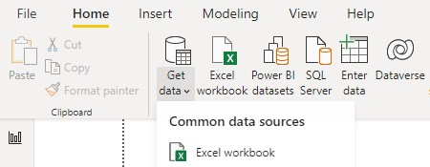

Step 3:- Browse to the data file on your system and select

Step 4:- Once Data is loaded click on **Transform data** in the bottom for further transformation.

### 3.3 Data Transformation

In the Transformation Process, we will convert our original datasets with other necessary attributes format and change the features according to the problem statement on Power BI ETL tool Power Query as the data is in excel format.

A new Dim_ date table created for easy time intelligence analysis the features are:

1. Day of Week
2. Month name

3.Year

1. Year quarter
2. Month
3. Date

### 3.3 Data Modelling

After the data is transformed the data is modeled for visualizing and analysis.

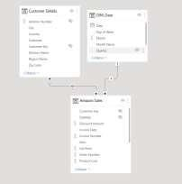

### 3.4 DEPLOYMENT:

After completing Dashboard Follow the Steps to deploy the report Step 1:- Click on **Publish** on the ribbon.

Step 2:- A box will pop just click on **my workplace** and **select**

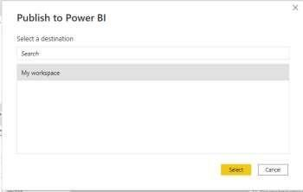

Step 3:- Now your report is published just click on open to check your report.

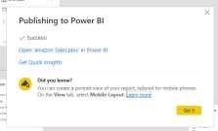

Step 4:- Report is published now explore your report

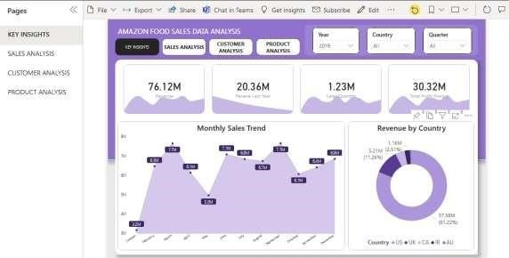

# 4. UNIT TEST CASES

|  |  |
| --- | --- |
| **Test Case** | **Description** |
| **Slicer of Year, Country & Quarter** | Slicer shows a drop down |
| **Top 20 product slicer** | Slicer show top 20 product and select works |
| **Charts** | All charts showing 0 error |
| **Tooltips** | Tooltips on various page working properly |
| **Page buttons** | Page buttons working properly |